6/8 Afro-Cuban: Basic Independence and Advanced Applications
© Marc Dicciani mdicciani@uarts.edu
As printed in the KoSA 2008 Conference Magazine

One of the most versatile rhythmic styles for drumset is Afro-Cuban 6/8. It is also one of the most transferable rhythms that can be easily adapted and incorporated into countless other styles of drumming and music from jazz to rock to hip-hop. Because the sub-division can be thought of as 3 or 6 per beat or measure, it blends with many other styles.

If you’d like to develop this kind of playing flexibility, it’s important that you also develop your comfort, knowledge, and skill with basic 6/8 independence, as well as some alternate interpretations.

Here are some simple, and not-so-simple, independence exercises for 6/8 patterns utilizing all four limbs, playing the top-line rhythm with the Right Hand, and the rhythm on the middle space of the staff with the Left Hand. Feel free to experiment and try using any sounds (drums, cowbells, jam blocks, rims, etc). Then, to develop more dexterity, try reversing the hand assignments and play the top line with the Left Hand and the rhythm on the middle space with the Right Hand.
Here are a few that demonstrate the versatility of 6/8 rhythms. These are also a bit more challenging, so practice them slowly.

This first one shows the interchangeability between 6/8 and simple 4/4 jazz. As you become more skilled at hearing this transition, feel free to add some left hand rhythms and independence to the patterns.

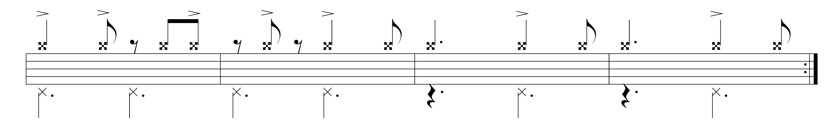
This next one shows how a 6/8 time signature and rhythmic pattern can be made to imply that you’ve changed the feel to that of straight-eighth rock. As you get comfortable with this one, be sure to play around with the accents, and even change the right hand rhythms for a more convincing ‘illusion’, if that’s what you’re after.
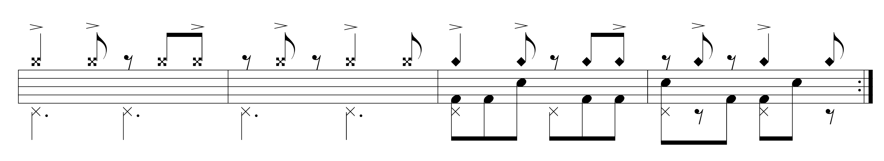

OK, this one is the most challenging of the group, as we move from a traditional 6/8 pattern for four measures, to one that feels like it’s a slow rock groove. This becomes more difficult as we change the left foot and right hand rhythms to make the transition sound more complete.

Make sure to experiment, create, and have some fun coming up with your own ideas!

